

**Weekly Lab Student Report**

Week 6 Lab

Lab Title: Application Data—Application Security

Student Name: Roman Kovtun

Date: 12/09/2018

**Lab Diagram**

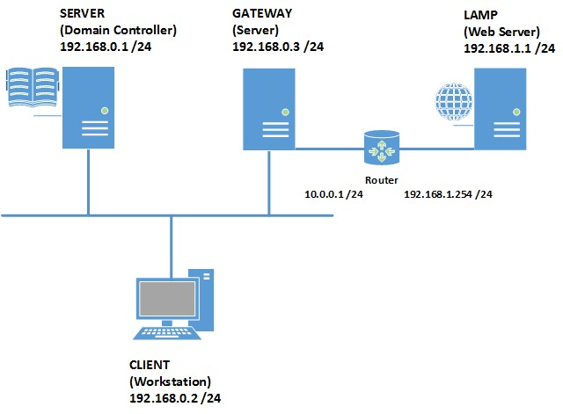

In this ilab, you will learn how to configure the different authentication methods in Internet information services and how to encrypt data in computers.

* You will test their security by capturing a network trace using *WireShark*.
* A way to protect user data in a workstation is by using an *encrypting file system (EFS).* It is important that a recovery agent certificate must be in place to recover encrypted data from a computer.

Paste your screenshots under the appropriate topic below.

1. Take a screenshot of Step 12 in Exercise 1 Task 1—configure basic authentication method. (5 points)

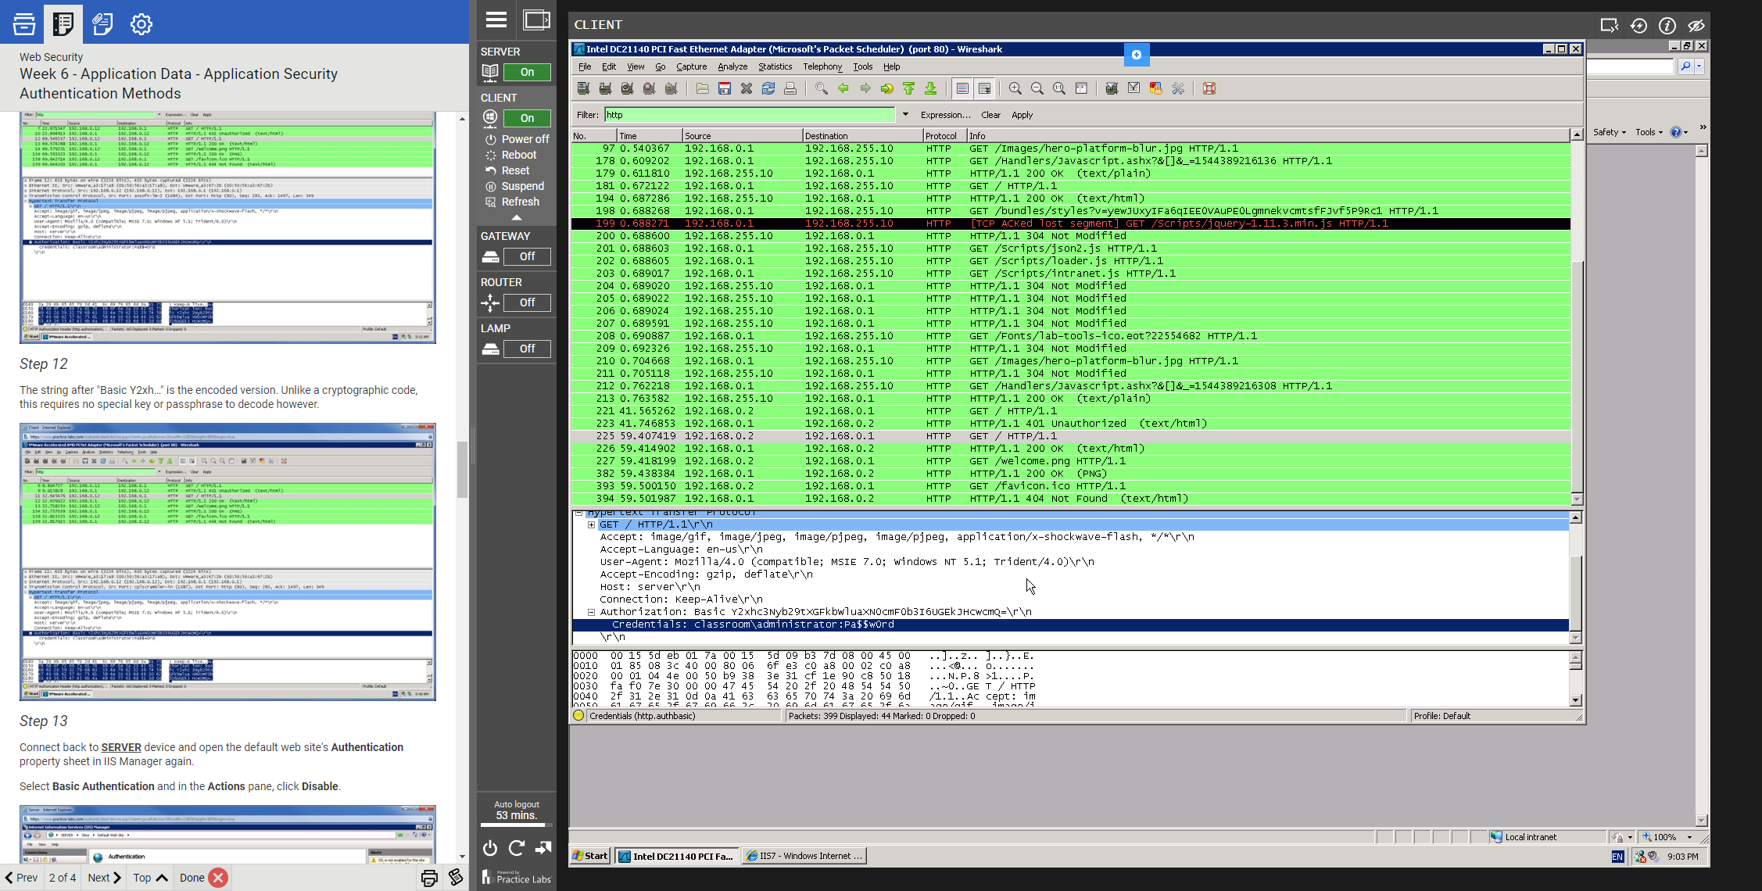

1. Take a screenshot of Step 21 in Exercise 1 Task 1—configure Windows authentication method. (5 points)

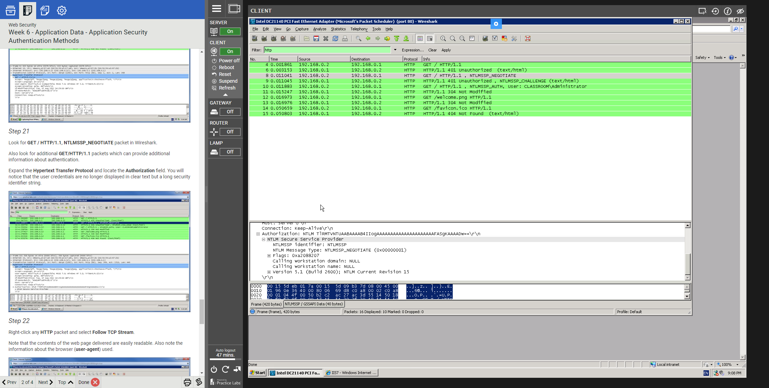

1. Take a screenshot of Step 7 of Exercise 2 Task 1—use data encryption recovery agent.   
   (10 points)

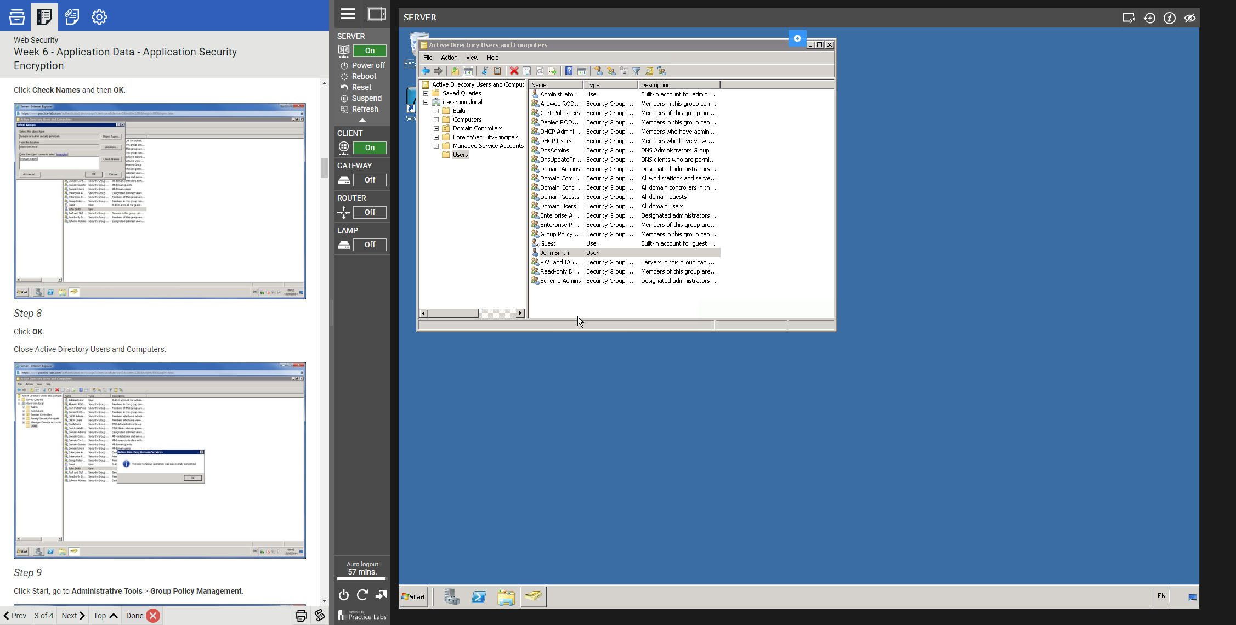

1. Take a screenshot of Step 17 in Task 1 of Exercise 2—exporting certificate. (10 points)

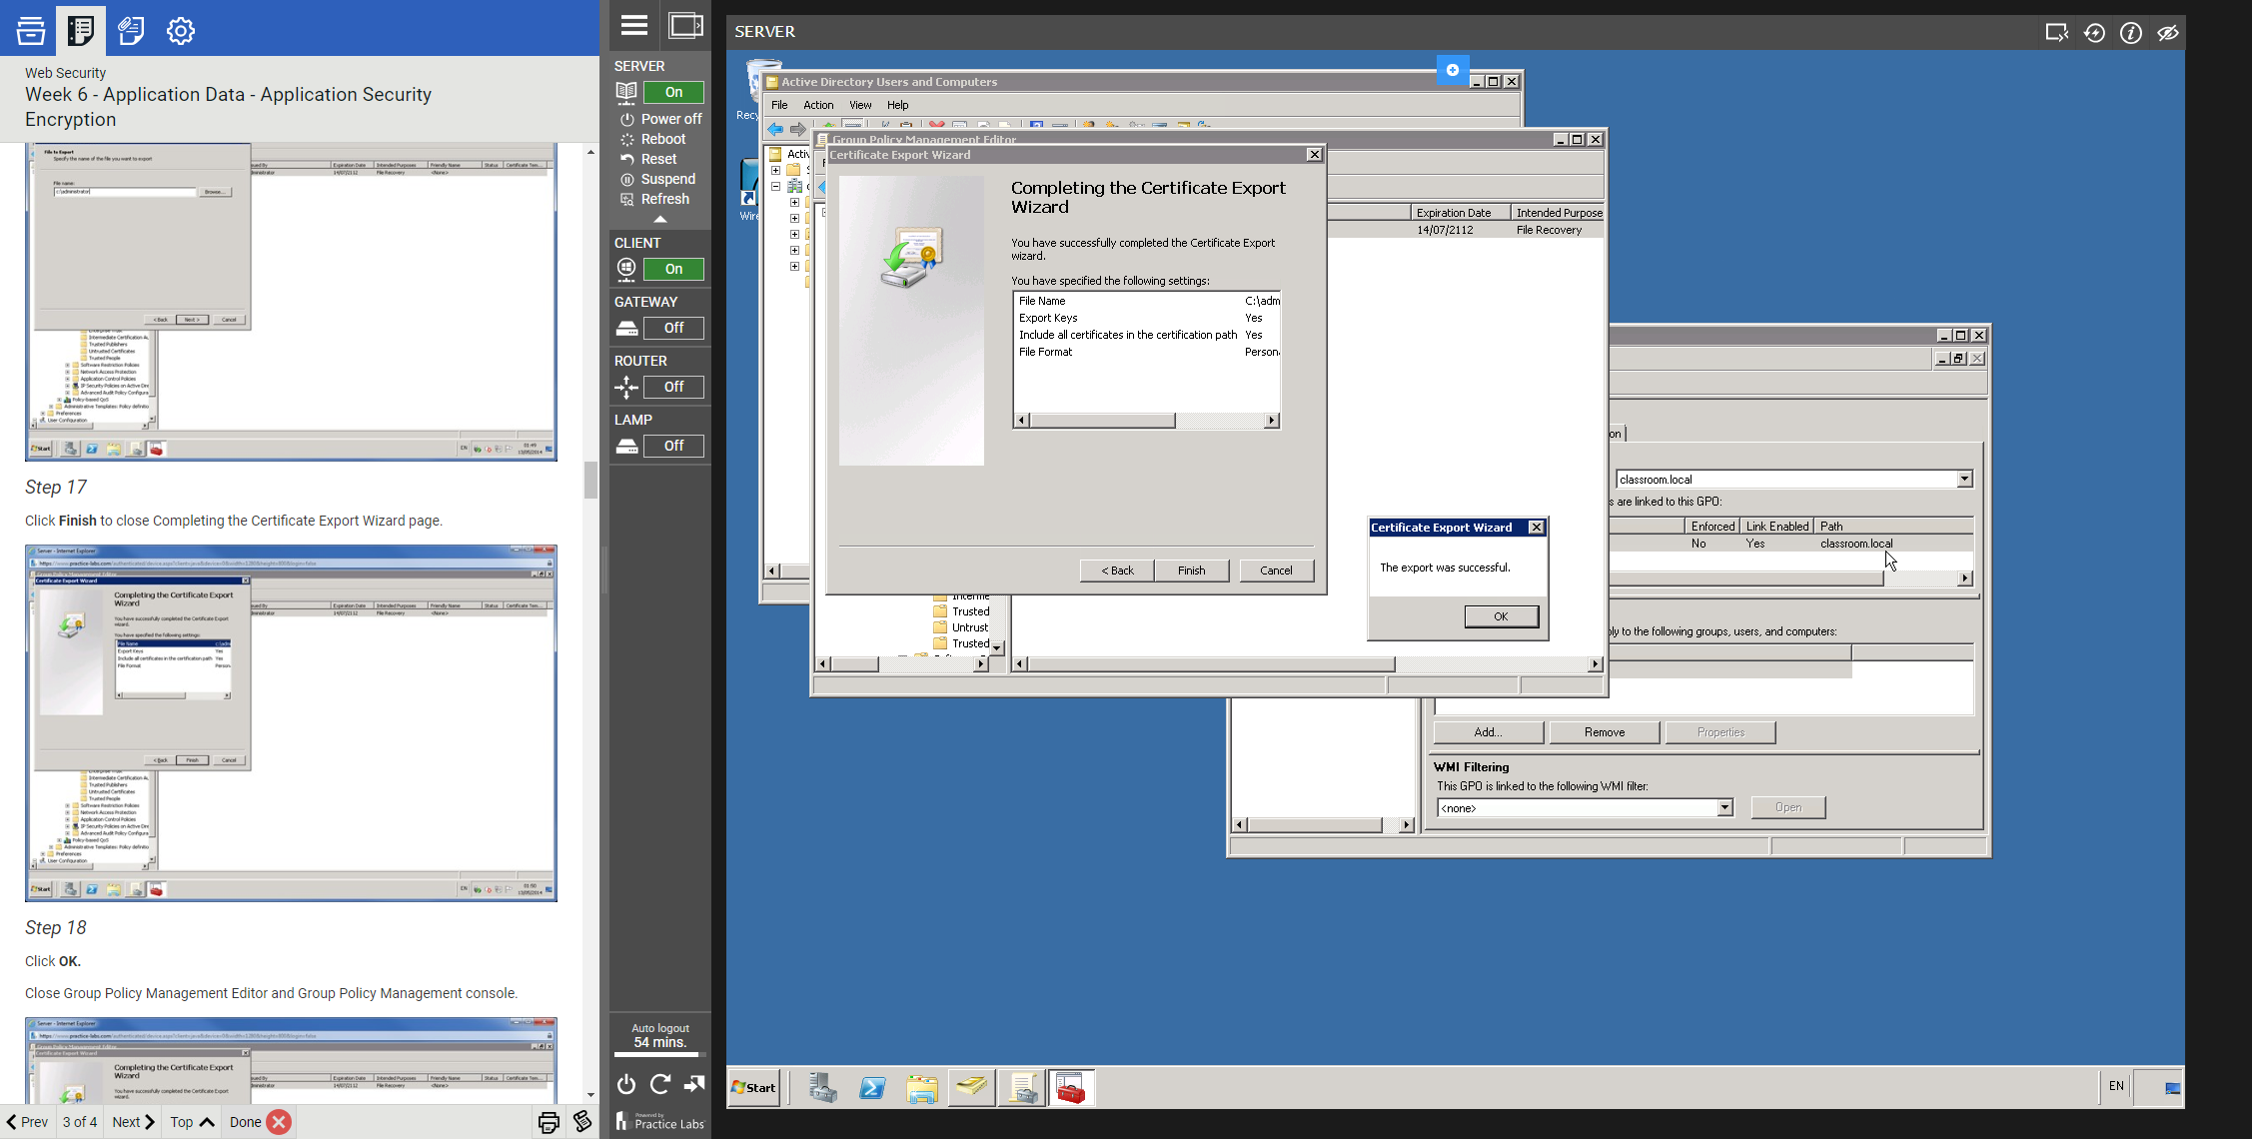

1. Take a screenshot of Step 13 in Task 2 of Exercise 2—testing data encryption. (10 points)  
   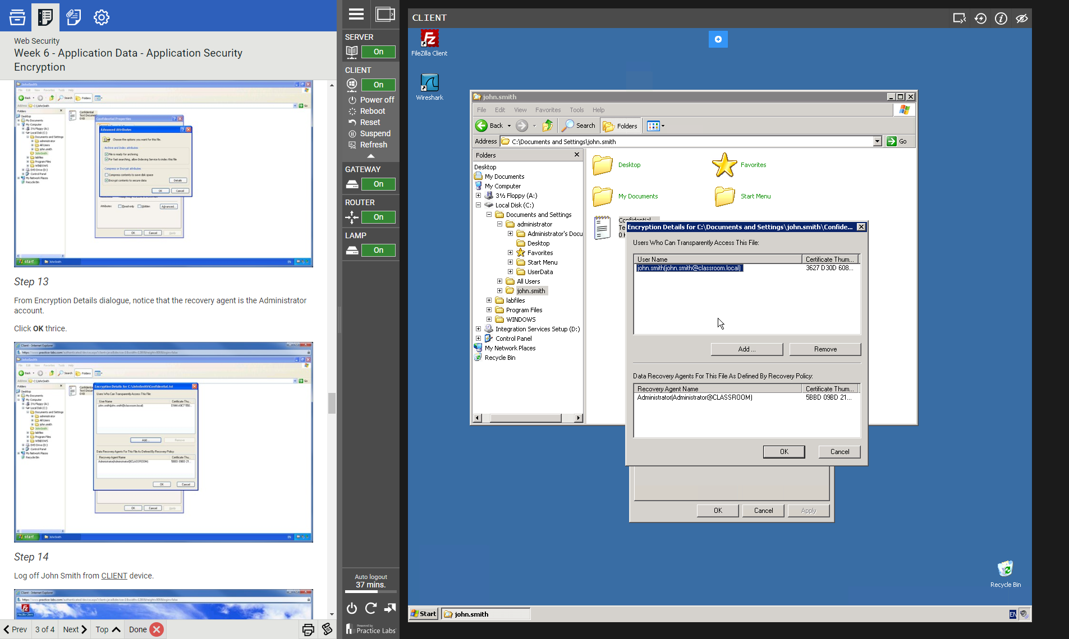
2. Take a screenshot of Step 17 in Task 3 of Exercise 2—export data recovery certificate. (10 points)

